**Survey insights**

**SERVICE VS FEATURES**

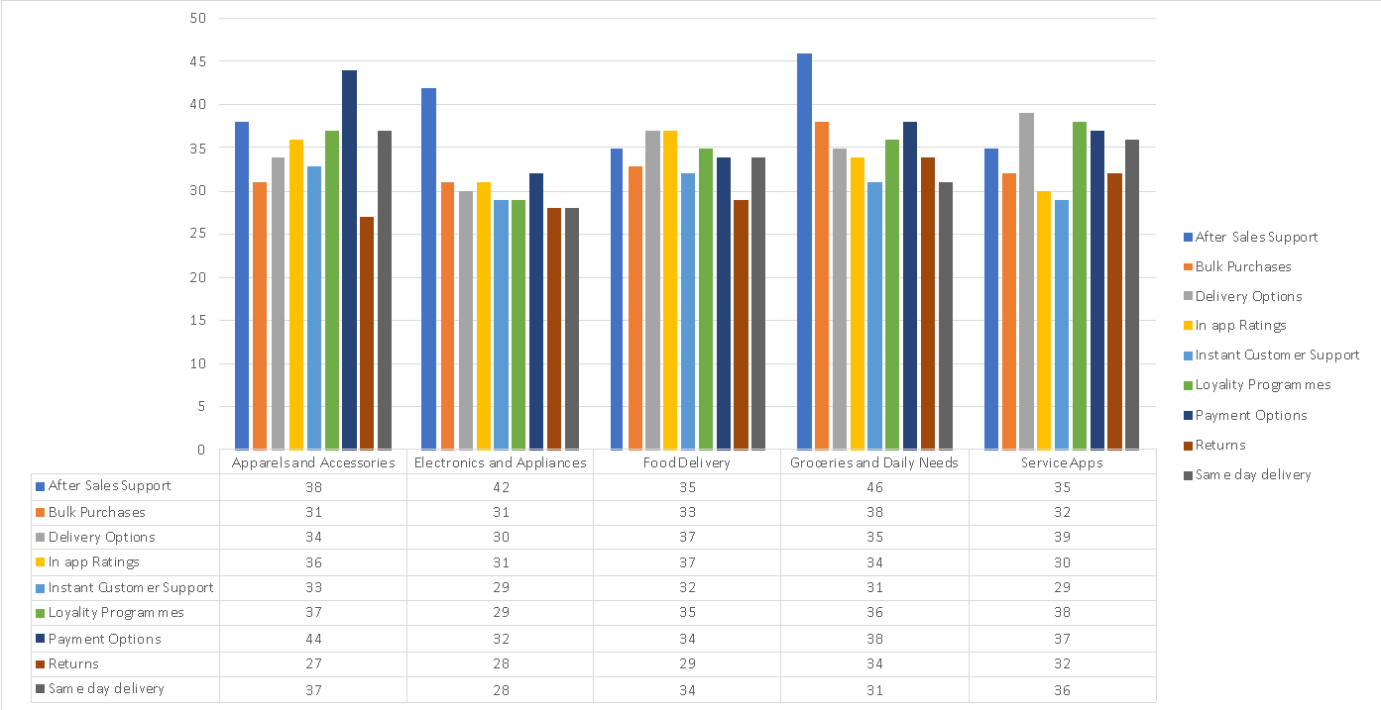

This graph is made to check important features and services based on the customer response. Responded who said very frequently and frequently in services and very important and important in features are selected together to gain insights.

From the above graph we can see that the following

* The People who shop apparel and accessories frequently need the payment options to be better and important
* Where as in the case of electronics after sales support was important and the same in the case of Groceries and daily needs
* More people are saying they would need for returns in groceries and daily needs, might be people who are facing quality issue in it
* The inapp ratings is slightly higher in case of food delivery
* The least important factor is returns in case of apparel

**Overall survey report**

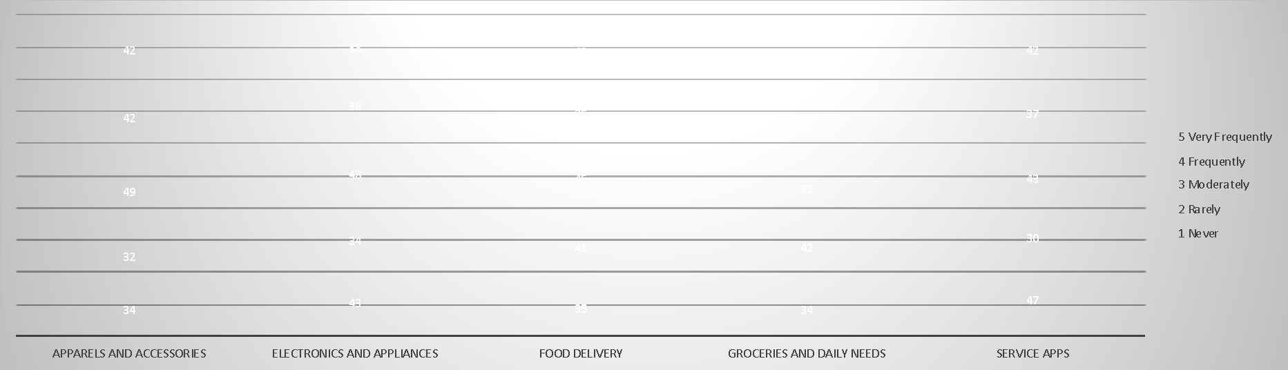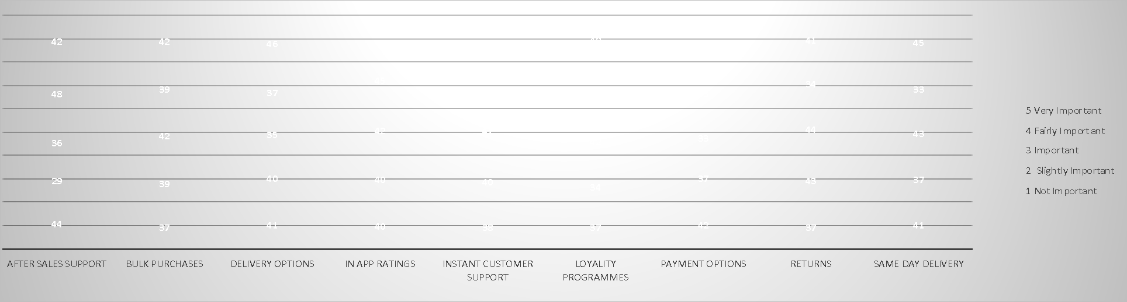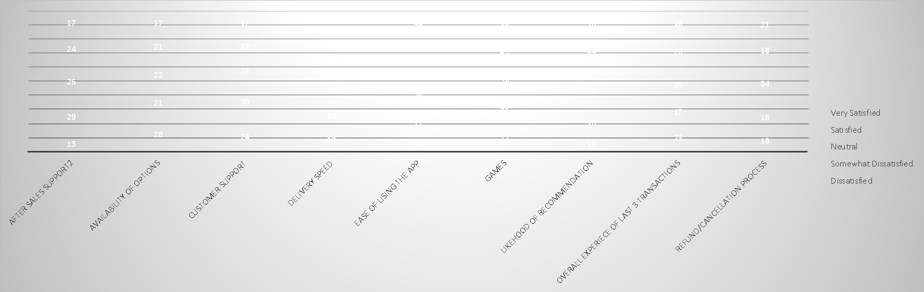

* Age 16-20 use more of service apps than any other apps and they are mostly interested in loyalty programs and freebies than that of any other services and the same with age 65+
* Groceries and food delivery are used more frequently than any other app services which makes us understand that there is more demand for these apps
* Delivery options and same day delivery is more preferred by our customers and the least being bulk purchases and payment options
* The existing customers are very satisfied with the current refund/ refunds policies and there are some challenges in options availability and customer support

**Pie support on importance and dissatisfaction of existing customers**

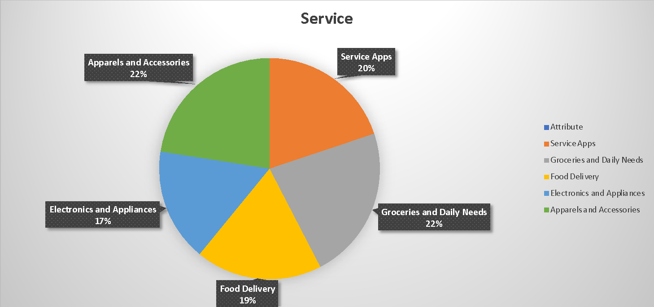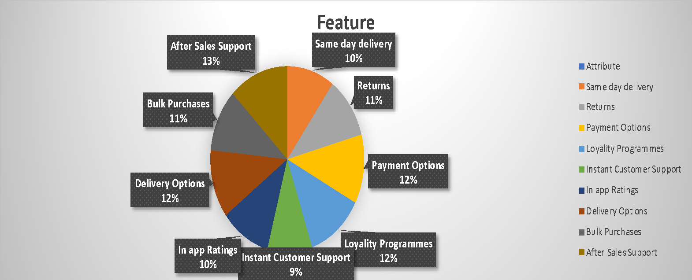

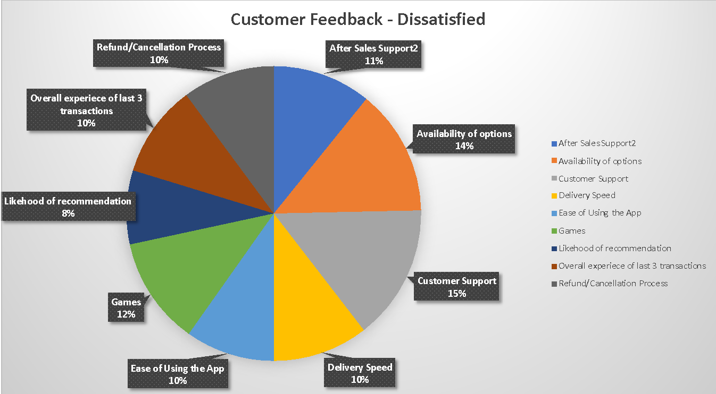

* in service apps the frequently used one is Groceries and Daily Needs and infrequent is Electronics and Appliances
* 66 people felt payment option is more important feature than any other feature
* The most satisfaction came from the ease of using app and we need to focus more on customer support as we got very less support in our survey
* The Highest amount of dissatisfaction is from customer support and definitely needs some improvement
* Also need more focus on the likelihood of recommendation as it is again dependant on the overall service